**Study of Basic, Advanced and Admin Commands**

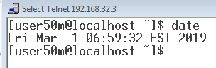

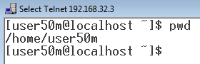

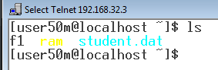

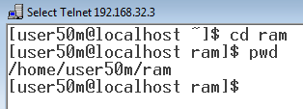

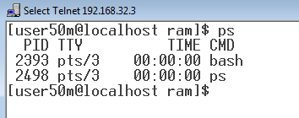

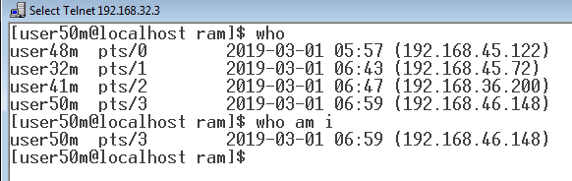

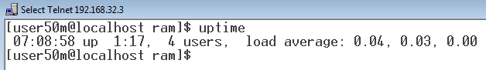

**Study of Control Statements**

1. **If Statement**

echo -e "\nProgram to check if the year is Leap year\n"

echo "Enter year: "

read a

result=`expr $a % 4 `

if [ $result == 0 ]

then

echo -e "\n$a is a leap year!\n"

else

echo -e "\n$a is not a leap year!\n"

fi

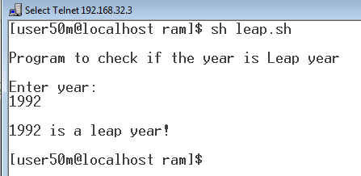

1. **Switch Statement**

echo "Area of shapes"

echo "Press 1 for circle"

echo "Press 2 for triangle"

echo "Press 3 for rectangle"

echo "Press 4 for square"

read var

case $var in

1) echo "Enter radius value(in cm): "

read radius

c=`expr 3.14\*$radius\*$radius |bc`

echo -e "\nArea of circle: $c sqcm\n"

;;

2) echo "Enter Base and Height value(in cm): "

read base height

c=`expr 0.5\*$base\*$height |bc`

echo -e "\nArea of triangle: $c sqcm\n"

;;

3) echo "Enter Length and Breadth value(in cm): "

read length breadth

c=`expr $length\*$breadth |bc`

echo -e "\nArea of rectangle: $c sqcm\n"

;;

4) echo "Enter side value(in cm): "

read side

c=`expr $side\*$side |bc`

echo -e "\nArea of square: $c sqcm\n"

;;

*) exit;;

esac

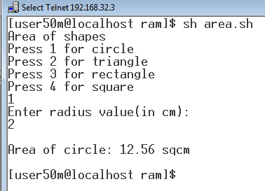

1. **Logical Operator**

echo -e "\nProgram to demonstrate Logical Operators\n"

echo -e "Enter 3 numbers: "

read a b c

if [ $a -gt $b -a $a -gt $c ]

then

echo -e " \n$a is the greatest number!\n"

elif [ $b -gt $a -a $b -gt $c ]

then

echo -e "\n$b is the greatest number!\n"

else

echo -e "\n$c is the greatest number!\n"

fi

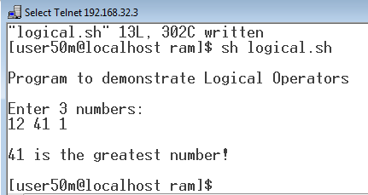

1. **While Loop**

echo "While Loop Program"

echo "Enter a number: "

read a

i=1

echo -e "\nTable of $a\n\n"

while [ $i -le 10 ]

do

result=`expr $a \* $i`

echo "$a x $i = $result"

i=`expr $i + 1`

done

echo -e "\n"

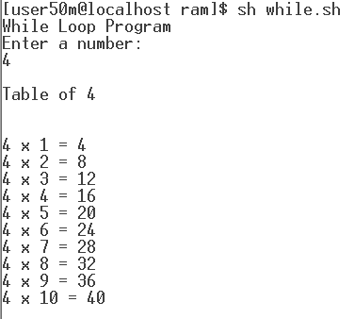

1. **For Loop**

echo "Multiplication Table"

echo "Enter a number: "

read a

var=1

echo -e "\nTable of $a\n"

for var in {1..10}

do

echo "$a x $var = `expr $a \* $var`"

done

